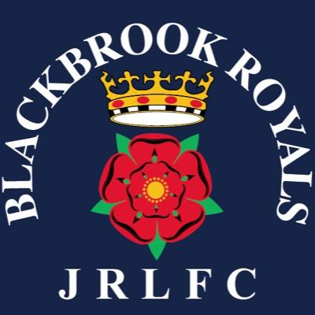

Blackbrook Royals JRLFC

Annual General Meeting Minutes held at Blackbrook Rugby Club 5/2/20.
Present ; Graham Roberts, Paul Levick, Chris Parsons, Paul Owens, Gareth Lowe, Gratton Palfrey, Mike Lee, James Kay. Phil Smith, Chris Hull, Donna Mather, Lisa Davies, Tracey Milne, Jane Harmon, Emma Cottington, Lesley Shryan, Selina Kent, Amanda Fryer, Jonny Lee, Gary Hughes, Julie Gibbons, Andy Bates.
Apologies; Neil Holliday, Andy Waddilove
Chairs report.
Minutes of the last AGM 2019 agreed.
GR referred to the Chairs report which gave a brief overview of the previous year’s achievements including;
RLWC 2021 funding, players forum, potential for the St Augustine’s project for a 4G facility which is hopefully planned for the Autumn.
State of Mind presentations.
New coaching initiatives with Saints RLFC and building community links and well - being initiatives.
Selina Kent was thanked for her work as Child Welfare Officer and Andy Waddilove and Ste Marsh as members of the Executive Committee.
Gratton and Alison Palfrey were thanked for their continued support in sponsoring the team kits with the ‘Storytime’ brand.
Treasurers Report.
CP stated the clubs have made a profit of 8000.00 this year, less transport costs, less coaching qualifications this maybe due to timing although CP states the club is in the best financial position we have been in for some time.
Executive Committee Positions agreed.
The following positions were formally proposed and seconded;
- Paul Levick Chair
- Vice Chair Graham Roberts
- Club Secretary Mike Mather
- Transfer Secretary Neil Holliday
- Child Welfare Officer Emma Cottington
- Treasurer Chris Parsons
- Exec Members Paul Owen, Emma Springford, Julie Gibbons, Mike Smethurst, Lesley Shryan, Selina Kent and Andy Bates.
- Julien Gibbons, Paul Owens and Mike Mather were formally welcomed to the club committee.
- AOB; General discussion about relationship with St Augustine’s, Registrations, pitch conditions, State of Mind presentations and knife crime initiatives.

