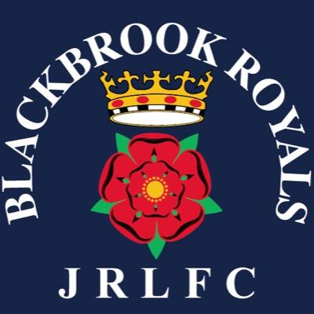

Blackbrook Royals JRLFC Committee Meeting Wednesday 22nd January 2020

In attendance Graham Roberts, Paul Levick, Selina Kent, Emma Springford, Andy Bates, Mike Smethurst, Chris Parsons, Emma Cottington, Chris Hull, Phil Anderton, Jane Harmon, Tracey Milne, Amanda Fryer, Jules Gibbons, Donna Mather
Apologies Gratton Palfrey, Neil Holliday, Andrew Benson
1. Discussion regarding ladies team
Bid is with RLWC 2021 team at the assessment stage and will shortly proceed to peer review
Lynn Doyle believes we have enough players for an Under 14s and Under 16s team.
Next steps Recruitment Training requirements Progress Funding Bid
Admin regarding team details Social Media Publicity Registration Day
2 .Subs will be ratified as a 15.00 increase as from 1st April at the Annual General Meeting on the 12th February, full amounts can be paid via bank transfer if people would prefer.
3. SOM Please ensure the money is in sync for State of Mind speak to Paul Owen and Chris Parsons.
4. Tracey Milne has agreed to look after future subscription admin. Only one player still to register, 7 coaches to register and PL will follow this up.
6. AGM people can still register for positions on the Exec.
7. Fencing around second team pitch to be costed - PL
7. Coaches session to be arranged with Paul Wellens and Kristian Woolf GR
8. 10 year canvas to be awarded for long service
9. All coaches and parent reps to ensure their teams attend the State of Mind session
10. AGM will now be 6.45 on the 5th February

