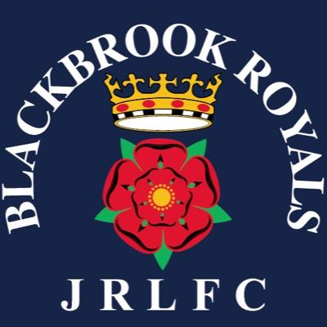

Blackbrook Royals JRLFC Committee Meeting Tuesday 18th June 2019 @Blackbrook.
Attendees Graham Roberts, Selina Kent, Emma Springford representing Under 7’s, Andy Waddilove, Lesley Shryan, Neil Holliday, Andy Bates, Lisa Davies, Tracey Milne, Ste Whalley, Chris Hull, Jane Harmon, Gratton Palfrey, Gareth Lowe, Ant Burns, Neil Winstanley, Yan Hodkinson, Craig Lyon.
A point was raised about post-match contact with Exec members on a Sunday. It was that people do not contact the exec unless it is a matter of urgency e.g. Serious child welfare issue or criminal matter etc.
Sunday 7th July is finals day. Gaz Swift will facilitate the logistical needs of NWC/RFL. NB. Now moved to 21st July. Car parking will be an issue but the school car park will be utilised to ease the burden.
All actions have from the May meeting been completed with exception of Advertising Boards, After Match Food and 10-year service recognition is still being worked upon.
No issues regarding subscriptions or finance.
Finance no issues.
Young Persons Forum. SK will arrange via What’s App Groups.
SK suggested a survey monkey approach to establishing what players and patents require in terms of food and facilities.
Paul Fass to assist with Respect boards.
Race Night will take place on September 13th.
Date of next meeting TBC.

