SAVE THE DATE!
RFL Safeguarding Annual Conference Sunday 21st January 2018
Venue to be confirmed

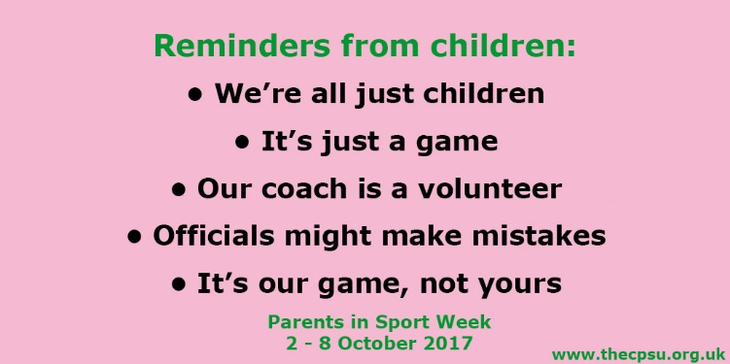
Parents in Sport Week 2 – 8th October 2017
The Rugby Football League is supporting the CSU Parents in Sport Week and would encourage all clubs to use this initiative to help ensure children and young people enjoy their rugby in a safe environment. The importance of positive support from parents and carers can be highlighted during the week.
Throughout the week the RFL will be tweeting the posters and we would ask that you show your support by retweeting them.

How parents contribute to their child’s rugby league experience
Rights and responsibilities
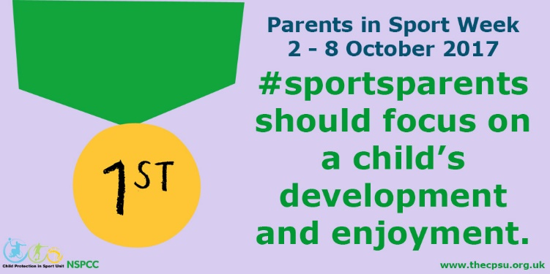
Just as we all have the right to take part in activities that we wish to, parents also have the right to question a club on their safeguarding before allowing their child to become part of that club and its environment. Encourage parents to ask questions about the qualifications of the Coaches, how the club carries out safer recruitment, what policies they have on anti-bullying etc. Clubs work hard to ensure they meet the safeguarding requirements and this can be your opportunity to show how well you do this. Parents should never feel that they should not be asking these questions. Responsible parents will choose a club that clearly demonstrates safeguarding practices and one that is a ‘Listening Club’
Parents should be informed of their responsibilities as a parent and spectator. The club does not want a hostile touchline that may scare and intimidate children. Children play primarily to have fun and this can only be achieved if they feel safe. An angry and abusive touchline will not promote a fun and safe environment – in fact children may leave the sport if they are afraid or unhappy on match days.
The way to ensure that the touchline is appropriate to children’s rugby league is to always ensure that you have a ‘good’ proactive Touchline Manager. This person should be appointed into this role because they are able to challenge in a positive way that defuses situations, rather than fuels them. When things go wrong on the touchline it is very frustrating to find that it is the touchline manager that has instigated the incident. Always ensure that you choose the right person for this role and that the committee support and back them up if they have concerns about individuals or a particular group of parents. Bringing a parent or group of parents up before the committee to receive a warning for inappropriate behaviour serves as a warning to other parents that this type of behaviour will not be tolerated.
You may need to work with parents to explain what is expected of them as sport parents. You may need to explain how a child will develop with positive input from both the parents and the coaches. You could hold a session with parents to discuss the type of comments they may use around the children, during and after games. Do the comments inspire the child or put them off and deflate them?
Have ‘rules’ that clearly state that parents should NEVER:
- Mock, verbally abuse or threaten their own child or any other player
- Criticise, mock or goad coaches, match officials, spectators, the opposition
- Threaten, abuse, or be aggressive to young players/officials or other adults
- Enter the field of play
- Try to influence team selection for a ‘win at all costs’ mentality
- Expect too much from their child, other children, the team, and the coach
- Contradict the advice, guidance and plans of the coach and coaching team
- Use their child to ‘score points’ with the coach
- Encourage foul play by their child or team
- Live out their own sporting dreams through their child
- Push talented children so hard that they want to leave the game because it is not fun anymore
- Define their child by their talent and success above everything else
- Criticise performance after a game
Everyone should realise that the game is about fun
That children play for their own reasons – it is their game, their choice to play or not
That children can get embarrassed by over aggressive, shouting parents on the touchline
They don’t want you criticising their team mates or coach
Children want praise after the game, not criticism – highlight the good points!
How bad parental behaviour affects young people
It's important to understand and acknowledge how poor parental behaviour affects children – whether it's your own child, other young participants, or young officials.
Children have told us:
‘I get really scared when they are all shouting at me.’
‘His dad was shouting, "You’re a disgrace to the family" – I felt really bad for him.’
‘Dad thinks he’s helping – but he just puts me off my game.’
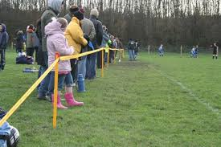
‘When mum starts yelling from the side, I feel so embarrassed.’
‘It doesn’t matter if I played well – if we lose they don’t even talk to me.’
‘They started fighting… I was terrified… I wanted to run away. ‘
’It’s confusing when the coach says, "Do this," but dad says do it different.’
‘When I don’t do as well as I should, I know mum feels I’ve let her down – even if she doesn’t say it.’
‘I just wanted to give it all up.’
‘He seems to forget that it’s my team.’
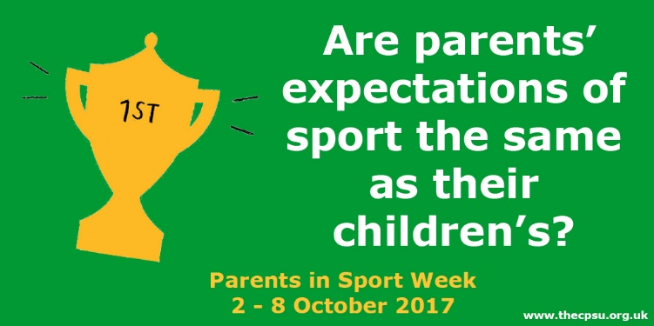
Positive things parents can do

•support your child enthusiastically
•encourage your child without expecting perfection
•be a good role model – to children and other parents
•promote fair play
•acknowledge the efforts of all the children
•encourage your child to play by the rules
•support the coaches and officials (particularly young officials)
•share challenges or criticisms (of officials, coaches, or players) in a constructive way
•encourage other spectators to be positive
•challenge or report poor touchline behaviour
•allow the coaches to coach
•support and respect your child’s ambitions in sport
•remember that this is your child’s sporting experience – not yours
•celebrate and support your child as a whole person who needs a range of experiences, both inside and outside sport
This is what we like to hear a child say:
‘My dad’s the best role model I could ask for. He was always on the touchline giving me great support and always encouraging me on – really good, really positive. He’s just an inspiration for me.’
‘My parents take me to training and games, week in week out and I know they will support me in whatever I want to do’
‘I make out that I am embarrassed by my Mums constant cheering and clapping at me and my team mates, but secretly – we all love it!’
(Adapted from the CPSU Parents in Sport Week)
There are many resources available on the CPSU website, including videos that you can show during training or match days if that is possible in your club.
You can find the resources by clicking here »
https://thecpsu.org.uk/news/2017/april/parents-in-sport-week-2017/

The Fist Listening Club Certificate Congratulations to Paul Harrison CWO and Heworth on being the first Listening Club. Emma Rosewarne, RFL Welfare Director, presented Heworth with their Certificate. Paul has conducted another Listening session with the U8s. It was interesting to note that they spoke about a ‘worry box’ Paul is going to progress this as this provides another opportunity for children to raise any concerns in a way that they can relate to. This is an excellent example of listening to children and responding to them.
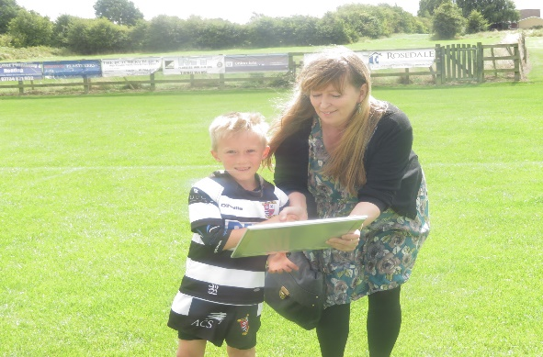
Emma Rosewarne, RFL Welfare Director, presenting the Listening Club Certificate to Heworth Players.

DBS and Risk Assessments
We do not carry out risk assessments for driving offences as these do not directly relate to working with children. If you require a volunteer to carry out driving duties with children then you should check their details to ensure they are appropriate as drivers for your club. You would not be required to check drivers details if they are not performing an official role for the club (such as parents taking other children in their cars to games etc as an informal arrangement between parents).

The theme for Anti-Bullying Week 2017 has been announced as:
‘All Different, All Equal’
Anti-Bullying Week runs from 13-17 November 2017 and provides an ideal opportunity to work with teams around the theme of being different and equal. This could be a theme for a listening session. If you would like some assistance in organising any workshops or events with your teams, please email safeguarding@rfl.uk.com We would also like to hear of any things that you have planned for this particular week.

The Danny Jones Defibrillator Fund has raised money that will help hundreds of community clubs and junior teams across the country to purchase a defibrillator, while helping raise awareness of the value of defibrillators as life saving devices to community clubs
Defibrillators cost around £1,000 each and provide potentially life-saving treatment to anyone suffering a cardiac arrest and clubs can apply to the Danny Jones Defibrillator Fund for a grant towards the purchase cost https://www.dannyjonesdefibfund.co.uk/grants
Time is critical for survival - several studies document the effects of time to defibrillation on survival from cardiac arrest and the consensus is that minutes count: If a rescuer can provide defibrillation in the first minute, the victim’s chance of survival increases to more than 90 percent. However, each minute that passes will decrease the victim’s chance of survival by 7–10 percent if no defibrillation is provided.

Make sure your club has a Defibrillator, that everyone knows where it is and how to use it.

